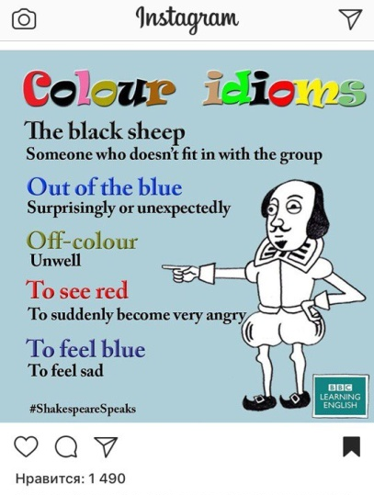

To see white – means the situation when someone’s Internet suddenly stops loading and person has to look at white web-page for a while.

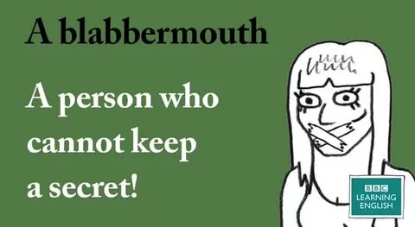
A latermouth – is a person who cannot fulfill his promise or forget it and always promise to do it a bit later.

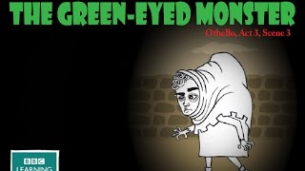
The red-eyed monster – is a student writing his thesis during the last week before the deadline.

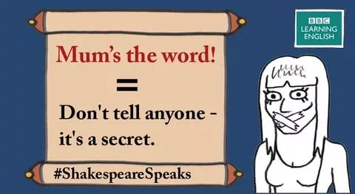

Teacher’s the word! The phrase means a set of collocations which can be clearly understood only by a group of teachers, for example “The bell is for teachers”, “Didn’t you forget your head at home?”, “Being ill is not an excuse for coming without your homework done”, etc.

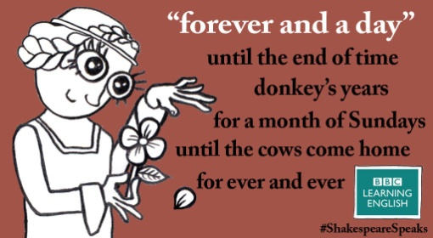

Never and as never before – the phrase is referred to people who always refuse to take leaflets from teenagers who try to save up money.

